**MITS5002-**

**Software Engineering Methodology**

Table of Contents

1. Specification Document 3

a. Executive Summary: 3

b. System Description: 3

c. Scope: 4

d. Feasibility Analysis: 4

e. Requirements Specification: 4

f. Assumptions/ Constraints: 5

g. Use Cases information: 5

Use Case Diagrams: 5

Use Case Description: 9

h. Context Model: 11

2. Design Document 12

a. Executive Summary: 12

b. Architectural Design: 12

c. Hardware Specification: 12

d. Detailed Class Diagram: 12

e. Wireframes Design: 13

f. Business Process Models (BPMN): 17

g. Sequence Diagram: 18

h. Interaction Diagram: 22

i. State Diagrams: 25

Figure 1: Use Case (System Functionality) 7

Figure 2: Use Case (Software Overview) 8

Figure 3: Use Case (Maintaining Members) 9

Figure 4: Use Case (Basic Functionality) 10

Figure 5: Class Diagram 14

Figure 6: Wireframe 1 15

Figure 7: Wireframe 2 16

Figure 8: Wireframe 3 17

Figure 9: Wireframe 4 18

Figure 10: BPMN 1 18

Figure 11: BPMN 2 19

Figure 12: BPMN 3 19

Figure 13: Sequence Diagram 1 20

Figure 14: Sequence Diagram 2 21

Figure 15: Sequence Diagram 3 22

Figure 16: Sequence Diagram 4 23

Figure 17: Interaction Diagram 1 24

Figure 18: Interaction Diagram 2 24

Figure 19: Interaction Diagram 3 25

Figure 20: Interaction Diagram 4 25

Figure 21: State Diagram 1 26

Figure 22: State Diagram 2 26

Figure 23: State Diagram 3 27

Figure 24: State Diagram 4 27

# 1. Specification Document

## a. Executive Summary:

The given case study is based on the MiBase computer procedure system and the MiBase toy management system has been selected for the research of this assignment. MiBase is a toy library management system and this is open-source software. The term open source means the source code of this assignment can easily be download from the internet. MiBase a cross-platform cloud based management system for toy libraries. This toy library management system is available for multiple operating system such as Linux, Windows and GNU also. This assignment is based on the implementation of this project. There are multiple of aspects are there which are associated to each other and every possible aspect related to this assignment will be define in this assignment report including several UML diagrams. Some of the components or elements are also available in this phase such as technology compatibility, database management system, user interface interaction, operating system compatibility and many more. The basic aim of this assignment is to define specification document and design document for the given assignment case study.

## b. System Description:

As defined in the above section this assignment is based on the Mibase open source software. A toy library management system is given for the successful completion of this assignment. This application is very use friendly and very easy to use also. There are multiple of implementation process are available that are associated to each other. This system is design specifically for toy libraries. To use this software there is no need of high system computability requirement. This software can easily run on minimal operating system requirements. This toy library will allow the user to design the new functionality based on this library management system. The barcode scanner functionality is also available on this implementation process that has an impact in the software development process. The library administration of this system has several of functionalities such as:

* There are multiple of categories are given of toys.
* The membership functionality is also available in this system which is used for the adjustable loan conditions.
* There are multiple of member functionality it means multiple member entry services functionality is available in this software system.
* The reservation functionality is also there which includes some of the basic components such as booking for event, returns, loan, renewal and many more.
* The user interface of this software is quite good and easy to use. The user can easily understand the basic requirements which is available on this system and the color combination which is used for the development of this system is also very attractive and user friendly.
* The compatibility of due amount for per members process functionality has been successfully implemented in this software.
* There are numerous of computer simultaneously services are implemented in this toy library management system that can be used on a single license to provide better efficiency and effectiveness process of the software development phase.
* To adjust the user requirement and other aspect an extensive configuration functionality can be used so that the library management system process can be provided by a simultaneously technological based services.
* The security features are also enables in MiBase toy library management system. For the security aspect the functionality of user management and logs has been enable and implemented in this phase that can ensure and provide the good security features aspect for the betterment of this software and to give more secure feature. The data accessibility and data confidentiality process are also available to give more safety features.

## c. Scope:

The case study which is given in this assignment clearly defines every possible functionality of MiBase database management system and the software is based on toy library management system. MiBase provides digital based system integration software for both cloud and desktop based system software application to toy libraries in Australia and New Zealand. The services provided by the MiBase is very efficient and accessible and having the functionality of affordability. Now this Mibase desktop provide the services of 300+ toy libraries at an affordable cost and prices. The service quality includes some basic approach like streamline, automate process, variable volunteer time and many more. This is an open source functionality and having the services in multiple other sectors also to provide the better services and functionality for the betterment of the technology based aspect. The database integration is one of the most important technology of this phase that is having the several of process of functionality and phase implementation of imitated technological based component.

## d. Feasibility Analysis:

The feasible analysis use to define and determine the viability for ensuring a project for legally and technical base aspect. The feasibility analysis can be categorize into several types such as technical feasibility, economic feasibility and legal feasibility. This MiBase toy library management has an effective technology based architecture process. There are multiple factors are available in this project such as toy registration, loan facility, return functionality, custom report generation and many more. Due to rapid advancement in IT, technical devices are available everywhere in affordable prices. Also it can be used by any kind of people who had little knowledge about computer & internet. So we can say that the project is technically possible.

## e. Requirements Specification:

**Functional Requirements:**

* Adding new features
* Membership categories
* Roster Preferences
* Renewing memberships functionality
* Age category and etc.

**Non-Functional Requirement:**

This project is very cost effective and the code can easily be change in this phase of this assignment. The process of availability, reliability, capacity, effective security, regulatory and many more are available in this phase. There should be most secure feature should be available in this so that no one can misuse the data of the customers and their respective members.

## f. Assumptions/ Constraints:

There is no proper security features are available in this toy library management system and there should be an effective security feature implemented in this software. The user interface can be more frequent and effective. The device compatibility is one of the most important concern in this phase that should be enable and should be implement to describe the effectiveness of this software system.

## g. Use Cases information:

### Use Case Diagrams:

**1. System Functionality:**

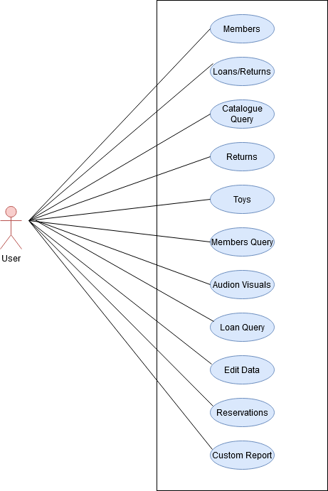

Figure 1: Use Case (System Functionality)

**2. Software Overview:**

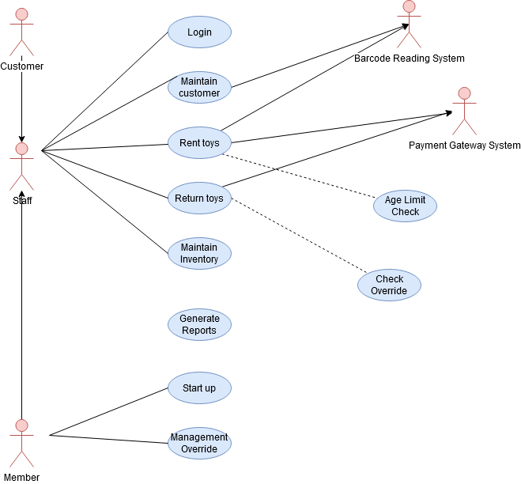

Figure 2: Use Case (Software Overview)

**3. Maintaining Members:**

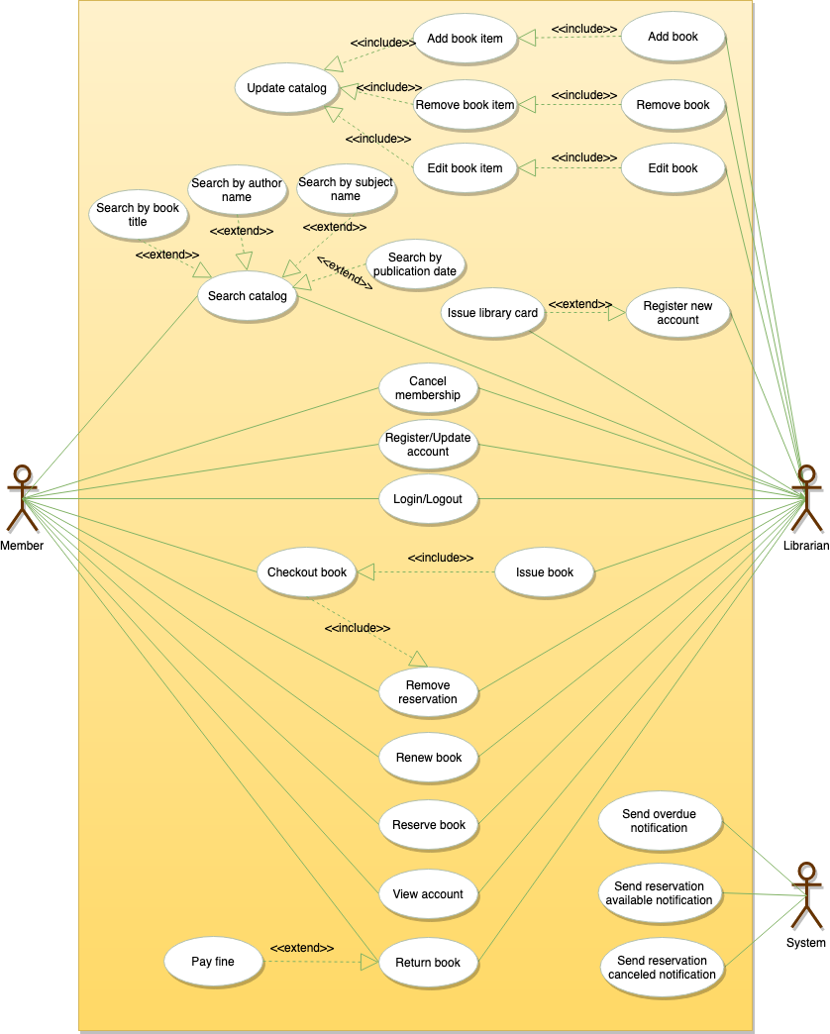

Figure 3: Use Case (Maintaining Members)

**4. Basic Functionality:**

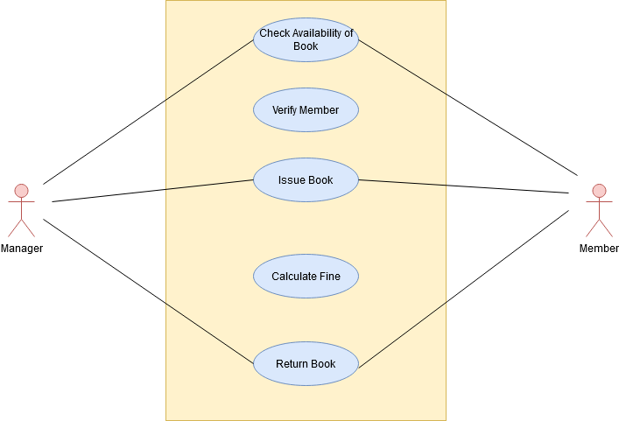

Figure 4: Use Case (Basic Functionality)

### Use Case Description:

**Software Overview:**

* **Title**: Software Overview
* **Description**: This use case is about the software overview. All the very basic functionality of this toy library management system has been clearly defined in this use case diagram.
* **Primary Actors**: Customer, Staff, Members, Barcode reading system and Payment Gateway System.
* **Program Flow**:
  1. Customer is directly associated to the staff and when customer or user register themselves then the staff administration get auto notification about the new registration process.
  2. There is a mutual interaction of customer and member with staff. Staff is one of the most important functionality of this system that has the capability of login, maintain customer, toys rent, toys return, inventory maintain and many more.
  3. The member is responsible for the computer startup and mibase login function. The reservation functionality use to define the member notifying the borrower system.
  4. The barcode reading system functionality and payment gateway system is also available which use to define the payment reminder and gateway functionality process.

**System Functionality:**

* **Title**: System functionality
* **Description**: This use case is about the system functionality process there are multiple use case objects are available.
* **Actors**: User
* **Program Flow**:
  1. The member is responsible for the reservation that has several of components of notifying the borrower, Reserve list, cancelling list and many more.
  2. Member maintenance is also there to effectively describe the membership categories, roster preferences and city name.
  3. Member features is having multiple components like missing parts, filtered view, locked members, renewing and many more.
  4. Roster event possibilities are there that has an impact in the application development of the software engineering.

**Maintaining Members:**

* **Title**: Maintaining members
* **Description:** This use case is about the maintaining members and system working progress and complete system functionality.
* **Program Flow**:
  1. Administrator of the system can add new product and manage also. For the rental toys process the permission of administrator is very necessary and there can be multiple enhancement.
  2. The membership cancelling facility and functionality is also available in this phase that has an impact for the development of the software products.
  3. The facility of book renewal, toy loan and return is also available in this phase that has an impact in the application development.

**Basic Functionality:**

* **Title:** Basic functionality
* **Description:** This use case is about the basic functionality of this software system with describing the minimal functions of this system.
* **Actors**: Manager and Member
* **Program Flow**:
  1. In this use case diagram the availability of book functionality is available that use to define the availability of the book at this stage of time.
  2. The number verification is also available and customer can verify the number of toy loan amount and custom report generation also.

## h. Context Model:

Context Model is one of the most important and most widely used type of modelling aspect in the process of software engineering. There are multiple of aspects are there which are associated to each other. Context model is used to define the basic activity and use based information of the software system. It is a combination of external and interaction between the multiple classes of the system approach that has an impact in the development of the software engineering based project. This operations of the system used to be define in this phase. In the given project there are multiple use cases are there such as:

* Member
* Customer
* Staff
* Toy Registration
* Loan Activity
* Return Activity
* Member Maintenance
* Custom Report Generation and etc.

# 2. Design Document

## a. Executive Summary:

This software system is based on the mibase toy library system which is having multiple implementation and features of the proposed system. The case study which is given in this assignment completely defines every possible aspect and the implementation process of this software system. The mibase developing language has been used for this phase. This system need a specific system compatibility availability to run this project. This is an open source project and can easily be download from the various different sources. In this section of design document every possible features and the aspect of the development and the diagram based architecture will be define. This software can easily be run on multiple operating system such as window and linux. During the installation process of this software system the server library file need to be in the same location where the actual file use to be state.

## b. Architectural Design:

In the implementation of the software engineering the architecture design process is also one of the most important aspect which is used to describe the design of the software product. The architecture design process use to collect the hardware and software requirement of the project that has an impact in the application development process. The interface and framework integration and implementation phase are available in this implementation phase that are somehow associated to each other. The computer-based architectural approach use to define the basic architectural designing implementation phase of any software development. This toy library management system is also having the same functionality that can be integrate to this process to achieve the different phase of the new technological based component.

## c. Hardware Specification:

There are some hardware specification based components are available such as:

* Previous version should be removed and completely uninstalled from the computer system.
* There should be at least 4 GB RAM and 205 GB hard drive space in computer system.
* The default version of this mibase software system is MiBaseV7 and to install all previous version should be removed from the computer system.

## d. Detailed Class Diagram:

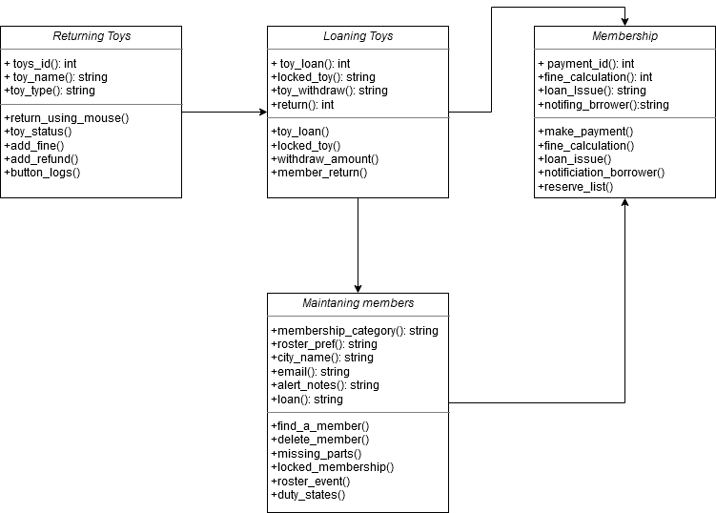

Figure 5: Class Diagram

## e. Wireframes Design:

**Wireframe 1:**

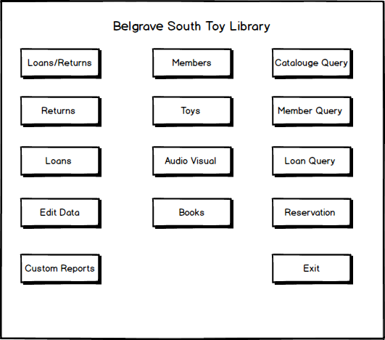

Figure 6: Wireframe 1

**Wireframe 2:**

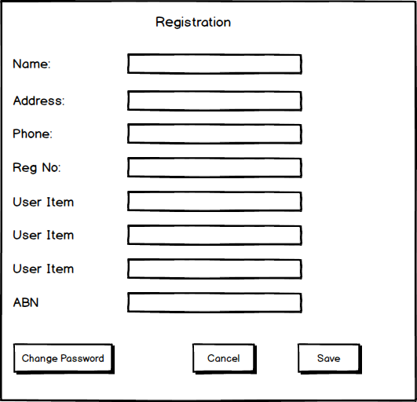

Figure 7: Wireframe 2

**Wireframe 3:**

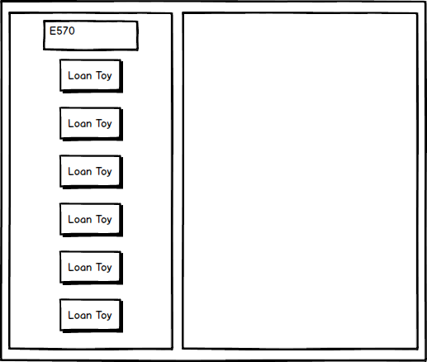

Figure 8: Wireframe 3

**Wireframe 4:**

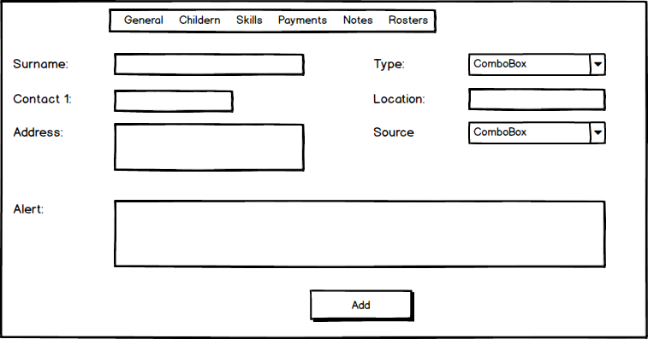

Figure 9: Wireframe 4

## f. Business Process Models (BPMN):

**BPMN 1:**

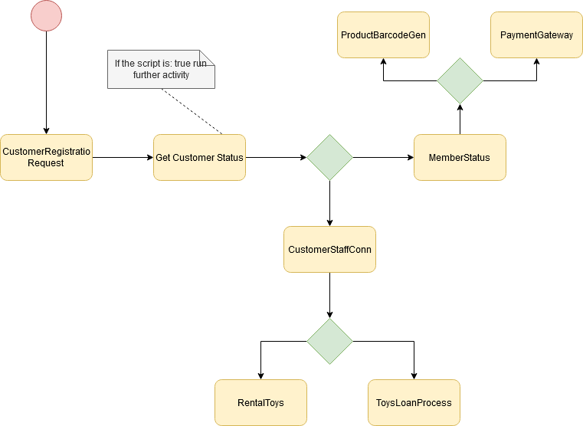

Figure 10: BPMN 1

**BPMN 2:**

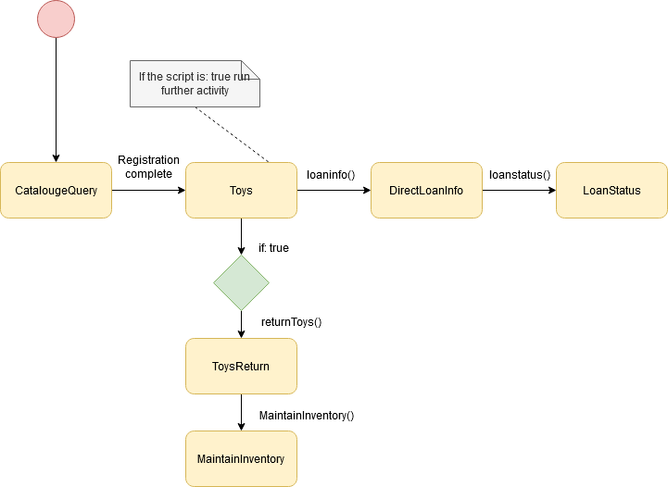

Figure 11: BPMN 2

**BPMN 3:**

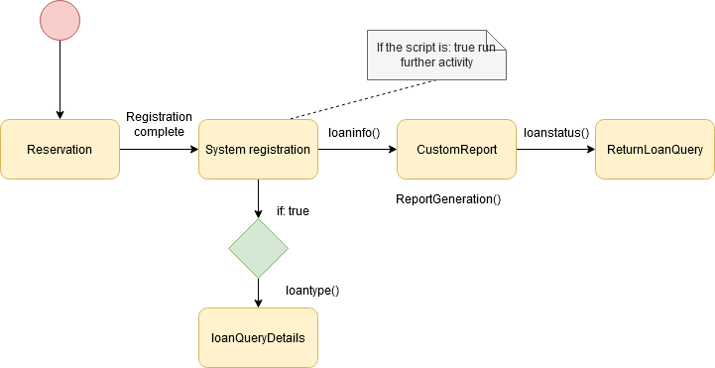

Figure 12: BPMN 3

## g. Sequence Diagram:

**Sequence Diagram 1:**

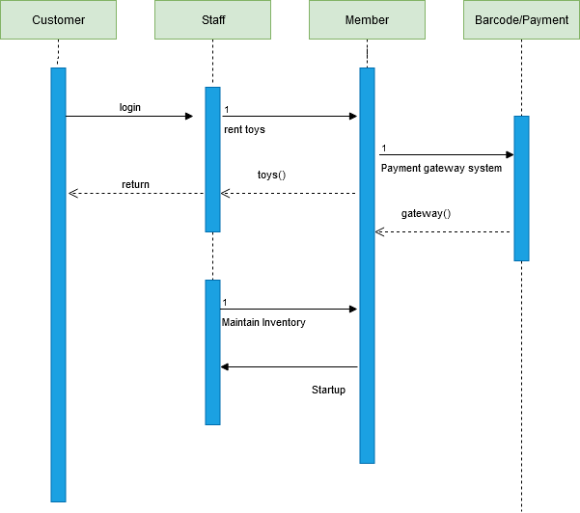

Figure 13: Sequence Diagram 1

**Sequence Diagram 2:**

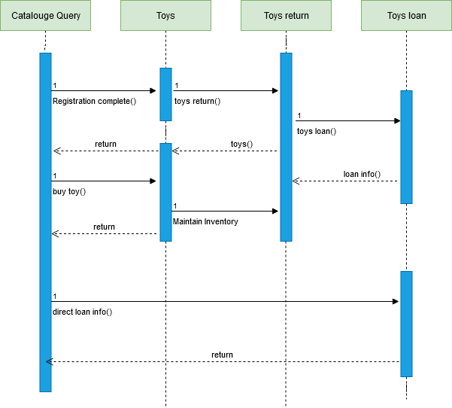

Figure 14: Sequence Diagram 2

**Sequence Diagram 3:**

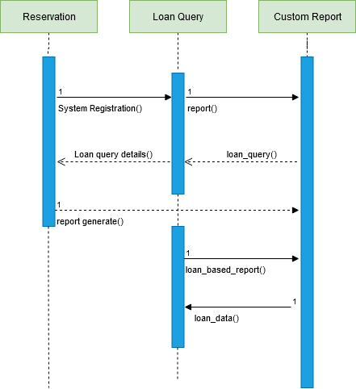

Figure 15: Sequence Diagram 3

**Sequence Diagram 4:**

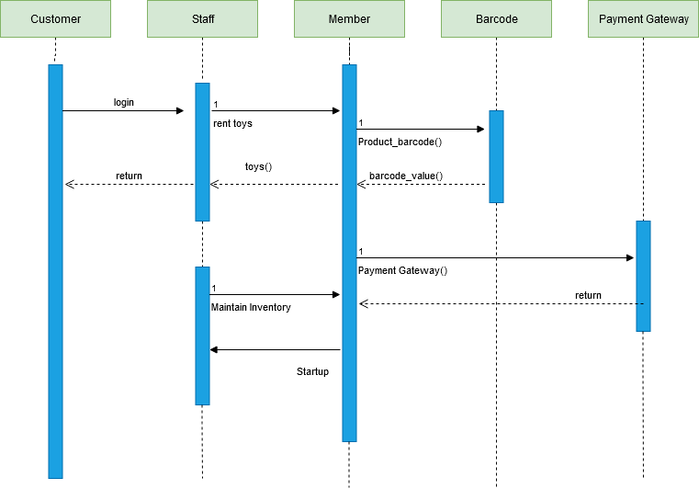

Figure 16: Sequence Diagram 4

## h. Interaction Diagram:

**Interaction Diagram 1:**

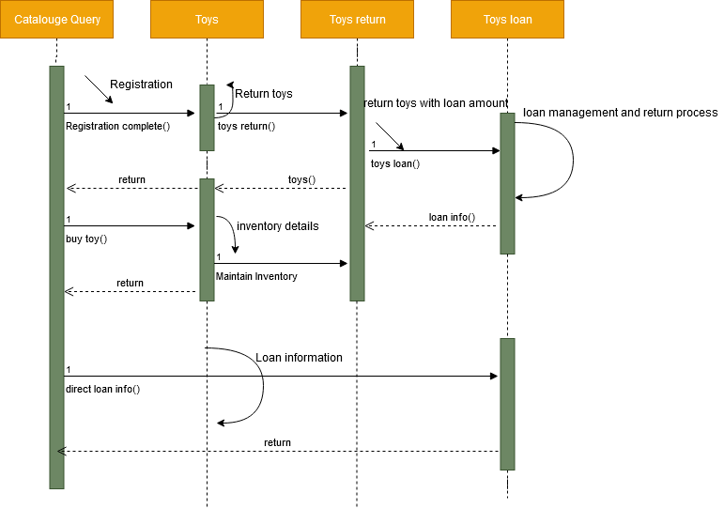

Figure 17: Interaction Diagram 1

**Interaction Diagram 2:**

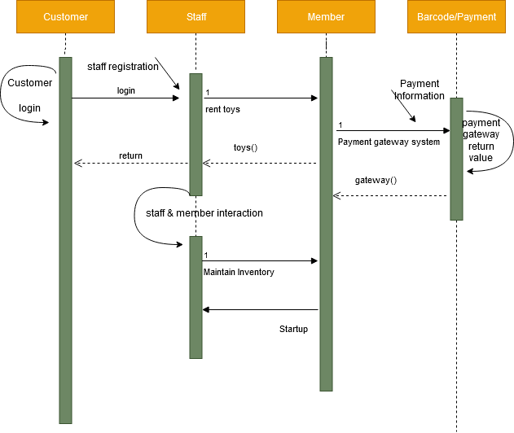

Figure 18: Interaction Diagram 2

**Interaction Diagram 3:**

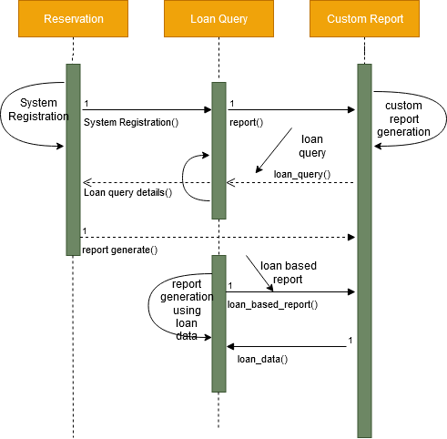

Figure 19: Interaction Diagram 3

**Interaction Diagram 4:**

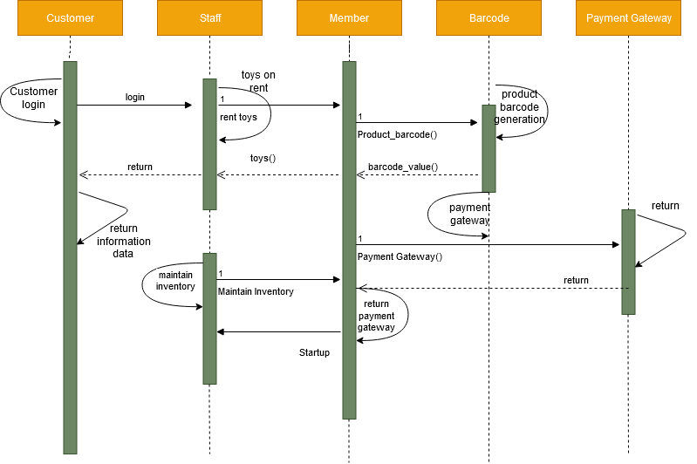

Figure 20: Interaction Diagram 4

## i. State Diagrams:

**State Diagram 1:**

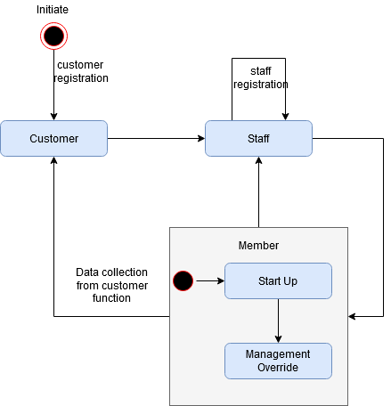

Figure 21: State Diagram 1

**State Diagram 2:**

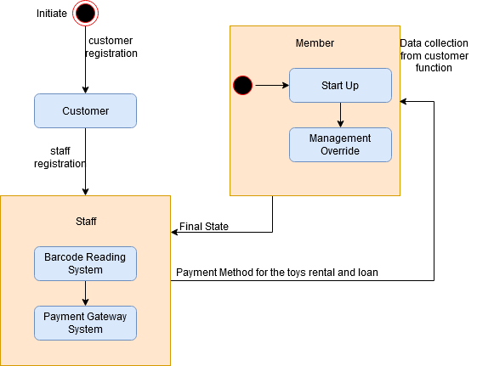

Figure 22: State Diagram 2

**State Diagram 3:**

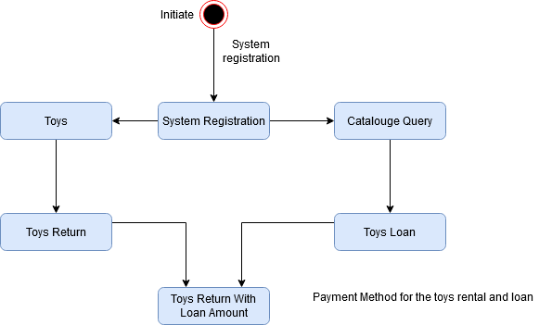

Figure 23: State Diagram 3

**State Diagram 4:**

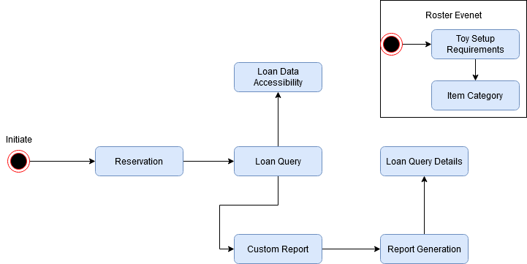

Figure 24: State Diagram 4